Chapter 2 Cells
Name: Class: Date:
extra worksheet 4: Cells, tissues and organs
Science understanding Visual/Spatial
1 Identify the definition on the right that matches with the term on the left.
Term |  | Definition
Tissue |  | The building blocks of all living things
Organ system |  | A structure that contains at least two different types of tissue that work together to complete a task
Cell |  | Two or more different organs that work together
Organ |  | A group of cells of the same type that carry out  the same job in the body
2 Propose which of the following diagrams represents cells, tissues or organs. Circle your selection.
a | 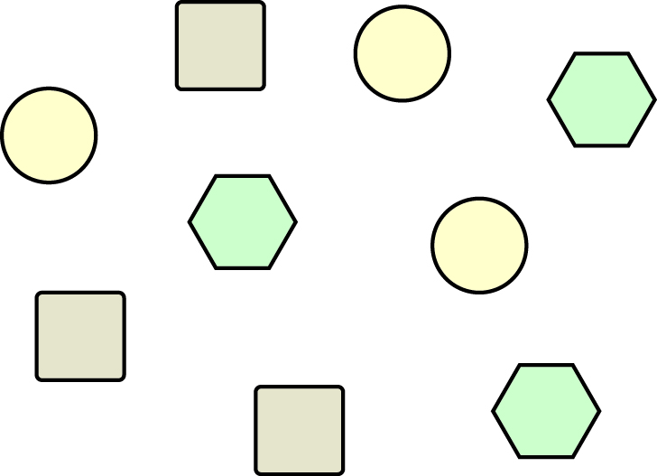 | Cells | Tissue | Organ
b | 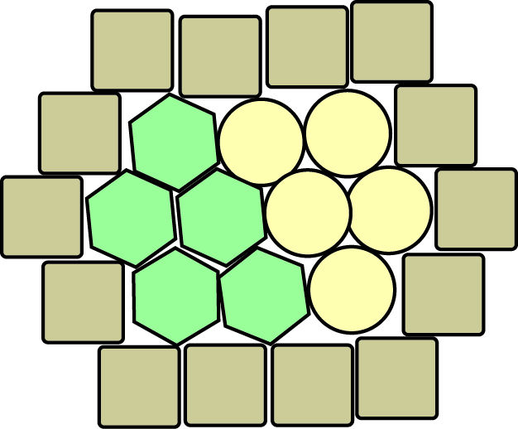 | Cells | Tissue | Organ
c | 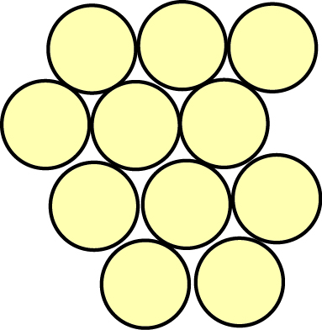 | Cells | Tissue | Organ
d | 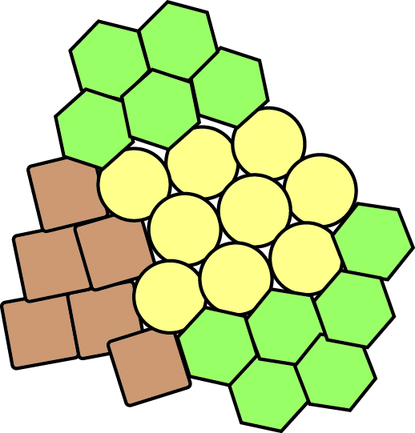 | Cells | Tissue | Organ
e | 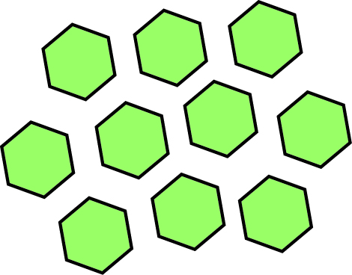 | Cells | Tissue | Organ

